Gheranda samhita postures, Hata yoga Pradipika postures are marked in yellow
Shalabasana cavalletta locusta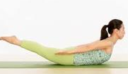 | Bhujangasana cobra 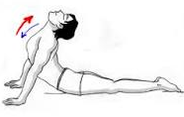 | Ustrasana cammello
Makarasana coccodrillo  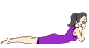 | Vrsasana bull  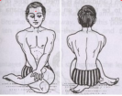 | Garudasana aquila  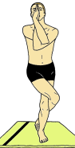
Vrksasana albero  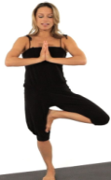 | Uttanamandukasana rana  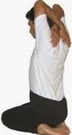 | Mandukasana rana  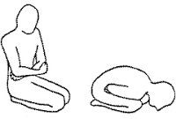
Uttanakurmasana tartaruga  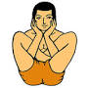 | Kurmasana tartaruga  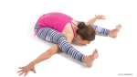 | Kukkutasana gallo  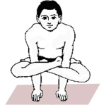
Mayurasana pavone  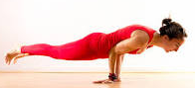 | Sankatasana  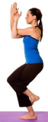 | Utkatasana sedia  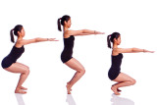
Paschinottanasana la pinza  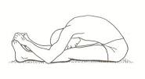 | Goraksana posizione di  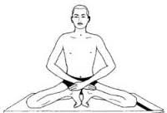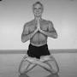 | Matsyendrasana nodo  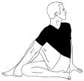
Matsyasana pesce  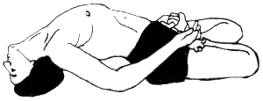 | Guptasana posizione perfetta  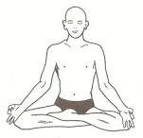 | Shavasana Mrtasana cadavere  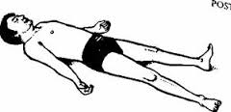
Dhanurasana arco  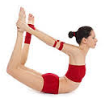 | Virasana eroe  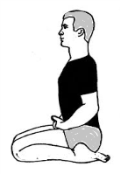 | Gomukhasana muso di vacca  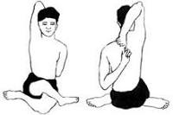
Simhasana leone  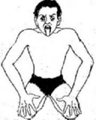 | Svastikasana attraverso  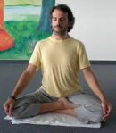 | Vajrasana fulmine  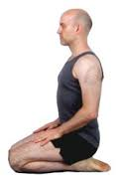
Muktasana posizione perfetta  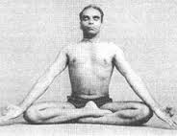 | Bhadrasana posizione felice  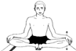 | Padmasana loto  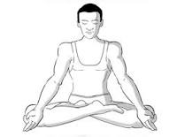
Siddhasana  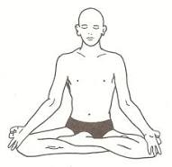 | In Hata yoga pradipika  Siddhasana, Vajrasana e Guptasana are different names for the same positions | In Hata Yoga Pradipika there are also these positions:  Kurmasana o Koormasana,  Uttana korm  and Shivasana

These thirty-asana have been found useful for mankind in this world.

